HONG KONG AIR CADET CORPS
Sung Wong Toi Road, Kowloon, Hong Kong
Tel 852 2712 8900 Fax 852 2715 6944

Skill Development Wing, Training Group
Foot Drill Training Flight
From： | OC FDTF |  | To | All applicants
Reference: |  |  | c.c.
Date | 2 July 2014 |  | Page | 4

No.4 Senior Drill Instructor Training Course Joining Instruction

- The following members are noted to attend the captioned course on the above shown.

No. | Unit | Rank | Name | Serial No.
1 | No. 4 Wg | Ag WO | YAU Chi-kin, Jacky | O-1862
2 | No. 1 Wg | Ag WO | HAU Sing, Park | O-2401
3 | C Wg | Instr | MO Ka-wai | O-2789
4 | C Sqn | WO | LEE Wing-san | O-1373
5 | 304 Sqn | Ag WO | KWOK Wai-yat | O-2494

- Training venue of 6 July, 13 July, and 27 July 2014 will be held at HKTAYYI Chan Lui Chung Tak Memorial School, 5 Ko Chiu Path Ko Chiu Road, Yau Tong, Kowloon. (Annex 1 : Map refers)

- Training venue of 20 July 2014 (optional) will be held at Hong Kong Adventure Corps - Hong Kong Jockey Club High Island Training Camp, Man Yee Road, Sai Kung, NT. (Annex2 : Map refers)

- Training Materials will be sent to candidates via email separately. All successful candidates should report to the Course Instructor in No. 2 Routine Working Dress (long sleeves with black tie) with SD Cap and laced shoes. No other optional item on uniform is allowed. Jersey blue-grey and foul weather jacket may wear if necessary.

- Candidates must sign on and off personally on the Attendance Sheet. After 0930 hrs on the first day, latecomer(s) will not be entertained throughout the whoe course unless a good cause. They should arrive at 0845 hrs sharp and bring along with stationery, course fee receipt, HKACC Drill Manual, course materials and open mind. Stud Drill shoes are not required. Car park is not provided; please make use of public transport.

- Candidates should have their own pace sticks (those comply with HKACC normal used type) with accessories.

- Should there be any queries, please contact the Course Instructor Ag WO ONG Bryan at 9361-8009 chiefdrillinstr@gmail.com .

( Signed )
( Julian Y Y LUI )
FDTF Trg Gp

c.c.: DCO Trg / OC Trg
OC Skills Dev. Wing
Drill Examiner / CDI
HQs

Annex1

HKTAYYI Chan Lui Chung Tak Memorial School,
5 Ko Chiu Path Ko Chiu Road, Yau Tong, Kowloon.

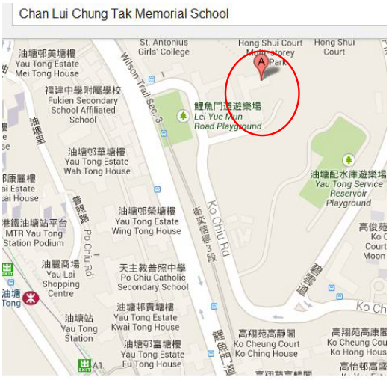

Annex2

Hong Kong Adventure Corps –
Hong Kong Jockey Club High Island Training Camp,
Man Yee Road, Sai Kung, NT.

